Security, Config & Networking
Security, configuration management, & networking form the foundation of any Azure architecture. Azure separates identity, authorization, secret management, application configuration, & network connectivity into specialized services that work together to provide a secure, reliable, & governed cloud environment. Microsoft Entra Id serves as the identity layer, IAM & RBAC provides authorization, Key Vault protects sensitive/confidential information, App Configuration centralizes application settings, & Virtual Networks provide network isolation & connectivity.
- Microsoft Entra ID deep dive
What is Microsoft Entra Id?
Microsoft Entra Id (formerly Azure Active Directory) is Microsoft’s cloud-based Identity & Access Management platform which is responsible for:
- Authentication of users, applications, & workloads
- Identity lifecycle management
- Single Sign-On (SSO)
- Access Governance
- Conditional Access
- Multi-Factor Authentication (MFA)
- Federation & external identities
Entra Id acts as the central authority that verifies identities before access to Azure resources or enterprise applications is granted.
Core components of Entra Id
- Tenant – is the logical boundary of an Entra Id instance
It has:
  - Users
  - Groups
  - Applications
  - Service Principles
  - Policies
  - Roles
Every Azure subscription is associated with an Entra Id tenant.
- Identities – Entra Id manages different identity types:
  - User Identities
  - Group Identities
  - Workload Identities
Authentication Process
Authentication answer:
“Who are you?”
Entra Id supports modern authentication protocols:
- OAuth 2.0 – Used for delegated authorization between applications.
- OpenID Connect (OIDC) – Adds identity verification on top of OAuth.
- SAML – Commonly used for enterprise SSO integrations.
- WS-Federation – Legacy enterprise federation protocol.
Conditional Access
Conditional Access is a policy engine that evaluates sign-in requests.
Evaluation factors may include:
- User Identity
- Device Health
- Location
- Risk Score
- Application being accessed
- Authentication strength
After evaluation, access can be:
- Granted/Allowed
- Denied/Blocked
- Partially Granted/Restricted
- Subject to additional controls
Conditional Access follows the principle of “Zero Trust Security”.
Multi-Factor Authentication (MFA)
MFA requires users to present multiple verification factors.
Identity Governance
Identity Governance ensures proper access management throughout a user’s lifecycle.
It includes capabilities such as:
- Access Reviews
- Entitlement Management
- Privileged Identity Management (PIM)
- Lifecycle Workflows
- App Registration & RBAC
App Registration
An app registration represents an application’s identity definition within Entra Id.
It establishes the trust between:
- Applications
- Uses
- APIs
- Azure Services
When application is registered:
- An Application Object is created
- Credentials can be assigned
- Permissions can be granted
- Tokens can be requested
Application Object
The Application Object is the blueprint of application which contains:
- Application ID
- Redirect URIs
- API Permissions
- Authentication Settings
- Certificates & Secrets
It defines how the application behaves.
Service Principal
A service principal is the tenant-specific instance of an application whose purpose is:
- Authentication
- Authorization
- Resource Access
The Application Object defines the application globally, while the Service Principal represents it locally inside a tenant.

Managed Identity
Managed Identity is a specialized Azure-managed Service Principal.
Advantages of Managed Identity
- No credential storage
- Automatic credential rotation
- Improved security posture
- Simplified authentication
Azure manages the identity lifecycle automatically.
Azure RBAC
What is RBAC?
RBAC is Azure’s authorization framework which answers “What are you allowed to do?”
RBAC assigns permissions to identities through roles
RBAC Components
- Security Principal
The identity receiving permissions can be:
  - User
  - Group
  - Service Principal
  - Managed Identity
- Role Definition
It defines allowed actions and contains:
  - Allowed Actions
  - Denied Actions
  - Data Actions
- Scope
It determines where permission apply. Scopes are hierarchical:
  - Management Group
  - Subscription
  - Resource Group
  - Resource
- Role Assignment
Defines the relationship among:
  - Identity
  - Role
  - Scope
- Azure Key Vault
It is a secure service for managing:
- Secrets
- Keys (Cryptographic Keys)
- Certificates
Its purpose is to isolate sensitive information from application code & infrastructure.
Key Vault Architecture
- Control Plane – Responsible for managing the vault itself.
It includes:
  - Creation
  - Configuration
  - Deletion
  - Access Management
- Data Plane – Responsible for managing stored data.
It includes:
  - Secret operations
  - Certificate operations
  - Key operations
Authentication is performed using Entra Id, while authorization is controlled through RBAC or supported access models.
Stored Objects
  - Secrets
  - Keys
  - Certificates
Key Vault Security Features
  - Soft Delete
  - Purge Protection
  - Access Control
  - Auditing
- App Configuration
Azure App Configuration is a centralized configuration management service with the following purpose:
  - Store application settings
  - Manage features flags
  - Support configuration versioning
  - Enable dynamic configuration updates
Configuration is organized as key-value pairs and provides:
  - Standardization
  - Centralization
  - Consistency
Comparing Azure Key Vault & App Configuration
Aspect | Azure Key Vault | Azure App Configuration
Primary Focus | Secure storage and management of sensitive information | Centralized management of application settings and configurations
Stores | Secrets, Keys, Certificates | Configuration settings, Feature Flags, Environment-specific configurations
Data Type | Security-sensitive information | Non-sensitive application settings
Security | Designed for highly secure storage with access controls, encryption, and auditing | Provides configuration management with integration to Key Vault for sensitive values
Typical Use Cases | Passwords, API keys, connection strings, certificates, encryption keys | Application settings, feature toggles, deployment configurations, environment settings
Configuration Management | Not intended for general application configuration management | Built specifically for configuration lifecycle management
Feature Flags Support | No | Yes
Environment-Specific Settings | Limited | Yes, with labeling and versioning support
Lifecycle Management | Focused on secret rotation and protection | Focused on configuration versioning, updates, and rollout management
Best For | Protecting and managing secrets and cryptographic assets | Managing application configuration across environments
Relationship | Stores sensitive values securely | Can reference secrets stored in Key Vault
Together | Provides secure secret management | Provides centralized configuration management

Recommended Usage
Store In Azure Key Vault | Store In Azure App Configuration
Database passwords | Application settings
API keys | Feature flags
TLS/SSL certificates | Environment-specific values
Encryption keys | UI/Business configuration
Connection string secrets | Non-sensitive connection strings
OAuth client secrets | Service endpoints

- Virtual Network design
What is an Azure Virtual Network (VNet)?
A Virtual Network is Azure’s fundamental networking construct which provides:
  - Isolation
  - Connectivity
  - Segmentation
  - Secure communication between resources
A VNet resembles a logically isolated network withing Azure.
Address Space Planning
Address Space design is the first stage of VNet architecture.
Considerations for Address Space design include:
  - Network Growth
  - Regional Expansion
  - Hybrid Connectivity
  - Multi-Subscription environments
Proper IP planning prevents overlap & routing conflicts.
Subnet Design
Subnets divide a VNet into smaller logical segments.
Benefits of Subnet
  - Security Isolation
  - Traffic Control
  - Resource Organization
  - Scalability
Subnet boundaries often align with workload or security zones.

Network Security Groups (NSG)
NSGs act as packet-filtering controls and usually contain rules based on:
  - Source
  - Destination
  - Protocol
  - Port
  - Direction
They enforce traffic restrictions at subnet or network interfaces levels.
Routing
Azure uses routing to determine packet paths. Route types include:
  - System Routes – Automatically created by Azure.
  - Custom Routes – Defined by administrators.
  - Propagated Routes – Learned through external connectivity mechanisms.
VNet Peering
VNet Peering connects multiple virtual networks. VNet Peering characteristics are:
  - Private Communication
  - Low Latency
  - High bandwidth
  - Independence of networks
VNet Peering enables scalable network architectures while maintaining separation.
Network Segmentation
Network segmentation divides workloads into security boundaries. Typical segmentation principles:
  - Application isolation
  - Environment separation
  - Trust boundaries
Separation is a core Zero Trust networking principle.
Private Connectivity
Private Connectivity limits exposure to public networks.
Benefits of Private Connectivity
  - Reduced attack surface
  - Enhanced compliance
  - Improved data protection
  - Controlled communication paths

High Availability Considerations
Virtual Network design should account for:
  - Fault tolerance
  - Redundancy
  - Geographic distribution
  - Disaster recovery
Network architecture should support continuous availability even during component failure.

Demo
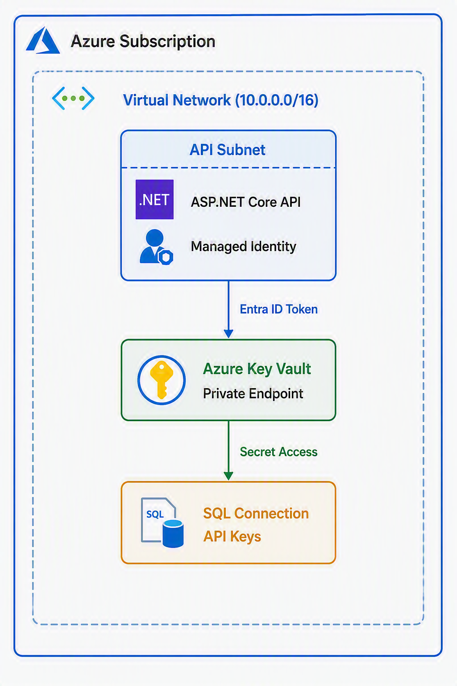

- Store secrets in Key Vault
- Secure APIs using Managed Identity
- Configure VNet + private endpoints

